CWA WORKGROUP
https://www.cityoftacoma.org/cms/One.aspx?portalId=169&pageId=163855
- What was the reason the group was established?
The group was established to examine and make recommendations regarding a Priority Hiring Ordinance (PHO) and a Community Workforce Agreement (CWA).

- What sorts of information was the group presented?
- Griffin & Strong Disparity Study
- Draft CWA & PHO
- Community Workforce Agreements(CWAs) and Priority Hire Ordinances
- Initiative 200 (PHOs)
- Presentation/Q&A: Public works hiring in Tacoma: current situation
- City’s public works contracting practices
- Public works contracting history and funding sources, types of procurements, existing City programs designed to promote diversity in hiring

- What are models that other cities/counties use for these issues?
- The Seattle CWA applies to public works projects over $5 million. It does not include WMBE hiring goals; the City of Seattle separately adopts a WMBE inclusion plan with aspirational goals for each public works project, and all bidders must meet certain minimum qualifications with respect to WMBE hiring in order to be considered a qualified bidder.
- Oakland MAPLA sets goals for the hiring of residents from the Port's LlA and LBA and requires Contractors to use reasonable and good faith efforts to achieve those goals.
- Cleveland and Cuyahoga County have taken a somewhat different approach than either a PLA or CWA to promote local hire goals: all companies receiving financial incentives agree to consider referrals from a state-sponsored workforce agency (there is one in each County in Ohio) and to hire qualified candidates from these agencies for available positions during the term of the incentive. These workforce agencies help bring employees and employers together and provide workforce training.
- Los Angeles Department of Public Works has an agreement called a PLA, but which applies to “all Covered Projects,” which makes it more akin to a CWA. The agreement does not include WMBE hiring requirements. It requires documentation of good faith effort of Unions and contractors to place “Transitional Workers” (Los Angeles residents who are veterans, homeless, involved with criminal justice system, impacted by other barriers to employment, residents of designated zip codes) on projects.
- King County and Sound Transit have PLAs – project specific agreements, rather than CWAs.

- What recommendations provided by the group are relevant to your work?
  - Implement race and gender conscious goals in public works contracting and hiring to the extent permitted by law to address existing disparities.
  - Commit to provide outreach, and train, mentor and support woman and minority contractors on any project subject to the CWA over $5 million

GRIFFIN & STRONG (GS) DISPARITY STUDY (EXECUTIVE SUMMARY & CONCLUSION) http://cms.cityoftacoma.org/CBCFiles/CommunityWorkforceAgreementTaskForce/Meeting%201/Tacoma%20-%20Final%20Study%20Report%20-%20Disparity%20Study.pdf
- What did GS find in their data?
- The City of Tacoma’s previous race neutral Small Business Enterprise (SBE) program has not been sufficient in promoting equity in public contracting, and SBE Project Goals lack Good Faith Efforts Requirements.
- The City employs policy tools to encourage Small Business Enterprise (SBE)/WMBE participation.
- Staffing and resource shortages prevent the program from reaching full effectiveness.
- African Americans, Asian Americans and Native Americans are the most underutilized minority groups

- Which of the recommendations do you feel will be the most impactful?
- Institute Race and Gender Based Subcontracting Goals
- Establish Supportive services
- Establish policy to investigate discrimination

EQUITY IN CONTRACTING (EIC)
Equity in Contracting - City of Tacoma
EIC Code: TMC 1.07 (starts at Page 57)

LEAP CODE
http://cms.cityoftacoma.org/cityclerk/Files/MunicipalCode/Title01-AdministrationAndPersonnel.PDF
- What are the groups that we make requirements around?
- City of Tacoma Residents
- Economically Distressed Areas of Tacoma Public Utilities (TPU) Service Area
- Apprentices of Tacoma Public Utilities (TPU) Service Area

- What is the Tacoma Public Utilities Service Area (TPUSA)?
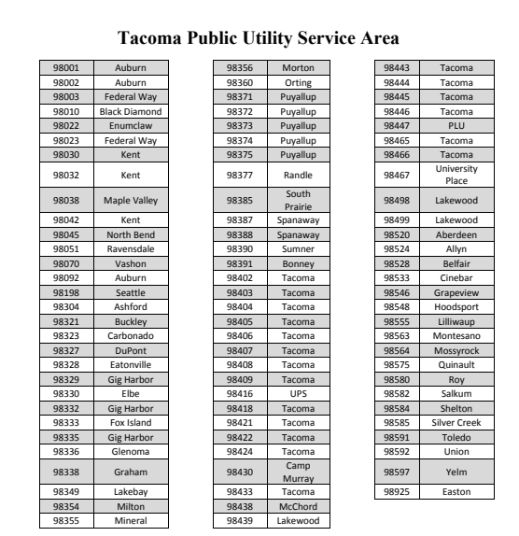

- What are the Economically Distressed Areas of the TPUSA?
  - TMC 1.90.030 (G). “Economically Distressed ZIP Codes” shall mean ZIP codes in the Tacoma Public Utilities Service Area that meet two out of three (2/3) of the thresholds of:
    - High concentrations of residents living under 200% of the federal poverty line in terms of persons per acre (69th percentile)
    - High concentrations of unemployed people in terms of persons per acre (45th percentile)
    - High concentrations of people 25 years or older without a college degree in terms of persons per acre (75th percentile) Said thresholds shall be updated within 30 days following any Prevailing Wage updates issued by the Washington State Labor and Industry. All updates are to be published on the first business day in August and in February of each calendar year
